RBCA Security Testing
This document contains test evidence for the Role-Based Access Control
implementation using Spring Security Basic Authentication.

Roles:
- ADMIN: Full CRUD access
- USER: Read-only access
- Test Cases

- TC-01: User can view all products
Field | Value
Endpoint | GET /http://localhost:8081/products
User | user/user123
Expected | 200 OK
Actual | 200 OK
Status | PASS
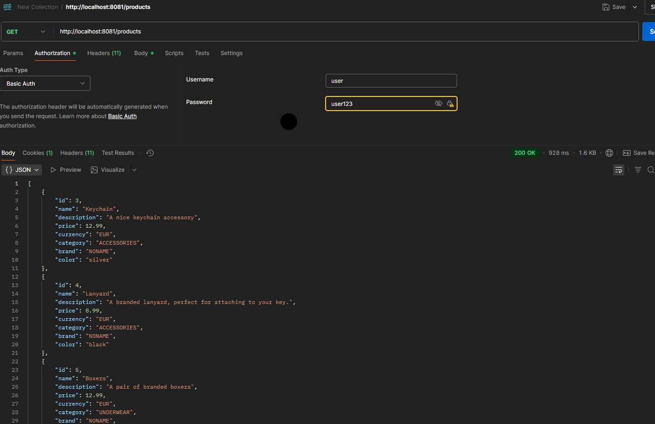

- TC-02: User can view product by id
Field | Value
Endpoint | GET /http://localhost:8081/products/2
User | user/user123
Expected | 200 OK
Actual | 200 OK
Status | PASS
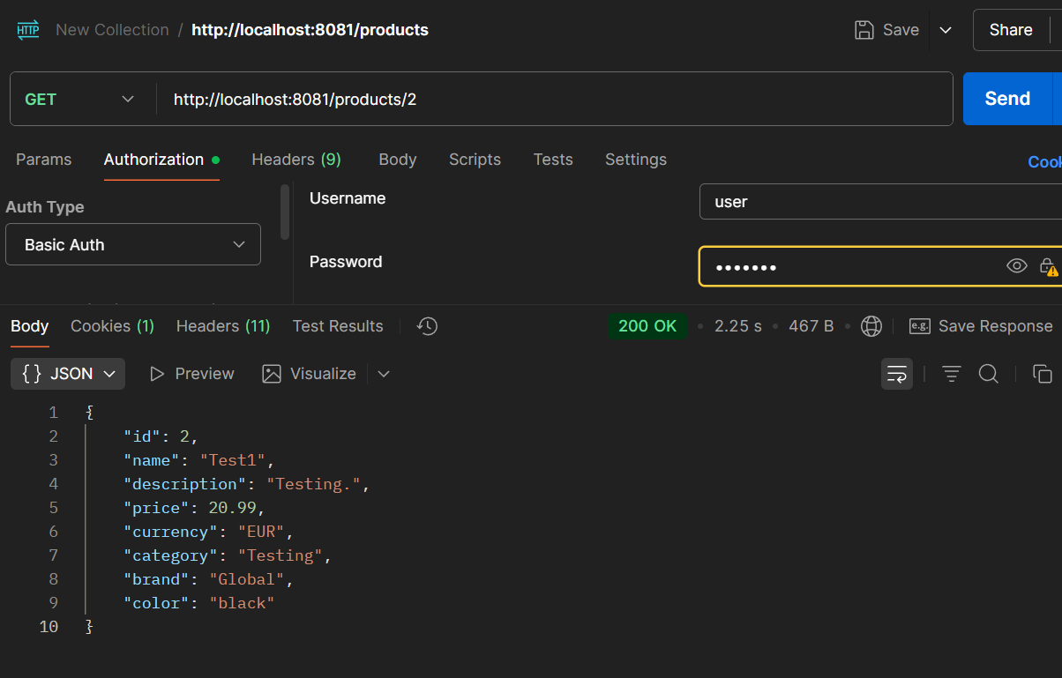

- TC-03: User cannot create product
Field | Value
Endpoint | POST /http://localhost:8081/products
User | user/user123
Expected | 403 Forbidden
Actual | 403 Forbidden
Status | PASS
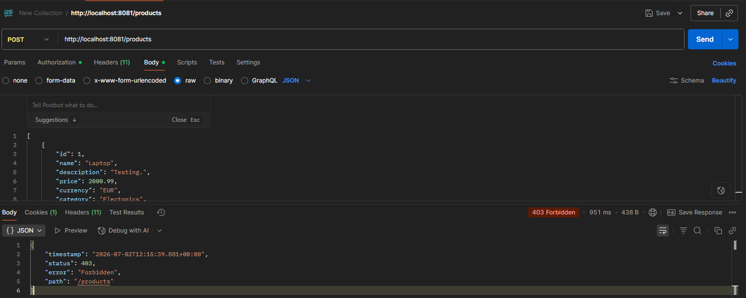

- TC-04: User cannot update product
Field | Value
Endpoint | PUT /http://localhost:8081/products/2
User | user/user123
Expected | 403 Forbidden
Actual | 403 Forbidden
Status | PASS

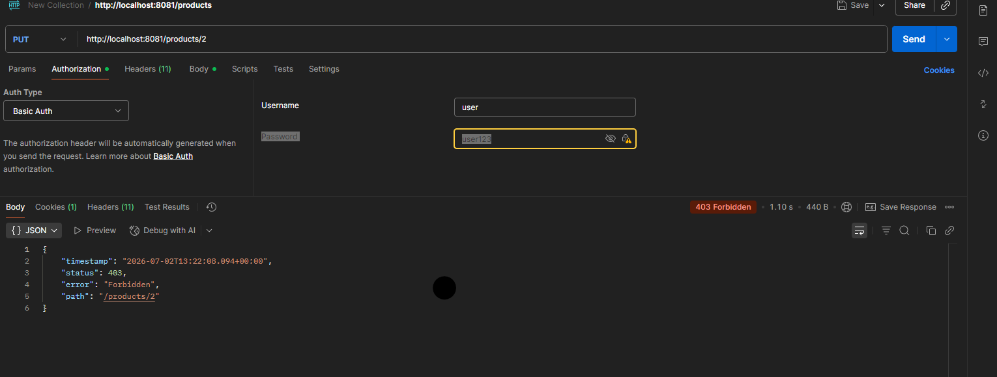

5. TC-05: User cannot delete product
Field | Value
Endpoint | DELETE /http://localhost:8081/products/2
User | user/user123
Expected | 403 Forbidden
Actual | 403 Forbidden
Status | PASS

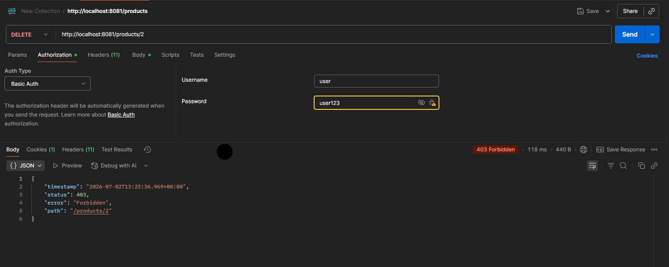

6. TC-06: ADMIN can create product
Field | Value
Endpoint | POST /http://localhost:8081/products
Admin | Admin/admin123
Expected | 200 OK
Actual | 200 OK
Status | PASS

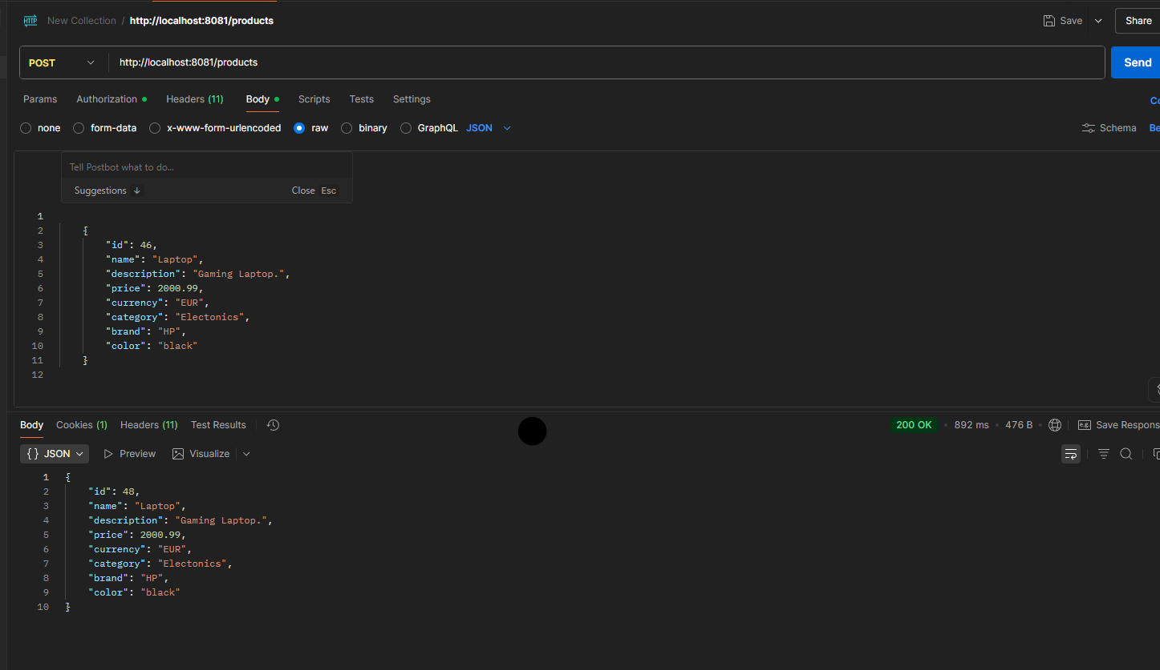
7. TC-07: ADMIN can update product
Field | Value
Endpoint | PUT /http://localhost:8081/products/3
Admin | Admin/admin123
Expected | 200 OK
Actual | 200 OK
Status | PASS

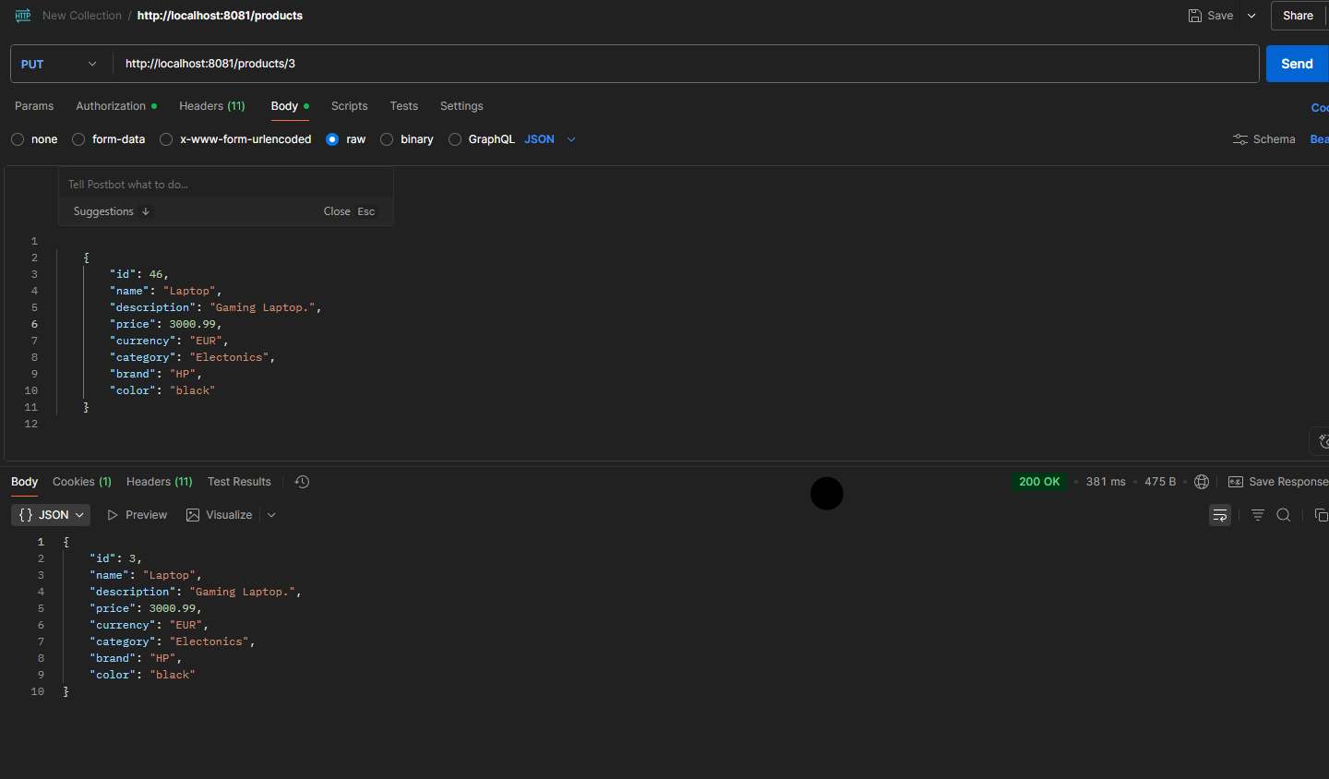
8. Unauthorised Access to perform operations. Wrong Credentials

Field | Value
Endpoint | PUT /http://localhost:8081/products/3
Admin | Admin/admin12345
Expected | 401 Unauthorised
Actual | 401 Unauthorised
Status | PASS

